**Project Topic :** Job Portal

**Group Members**

|  |  |  |
| --- | --- | --- |
| **Div** | **Roll no.** | **Name** |
| **B** | **407** | **PRAJAYSHEE CHAUHAN** |
| **B** | **436** | **GARGI PATHRUDKAR** |
| **B** | **450** | **RUPALI SINGH** |
| **B** | **438** | **SNEHAL PATTAM** |
| **B** | **432** | **OJASWI NANNAWARE** |
| **B** | **455** | **MANASI VEDPATHAK** |

**SCOPE OF THE SYSTEM**

1. Maintain job seeker and employer profiles.
2. Provide customized job postings.
3. Search job based on skills, company.
4. Manage job application status.
5. Maintain job details and generate various reports.

**Technology stack**

**List all front end, blackened technologies chosen for project :** Ruby and SQL LITE

**Proof of Concept**

1. **Add screenshot and code of sample UI developed using chosen front end technology.**

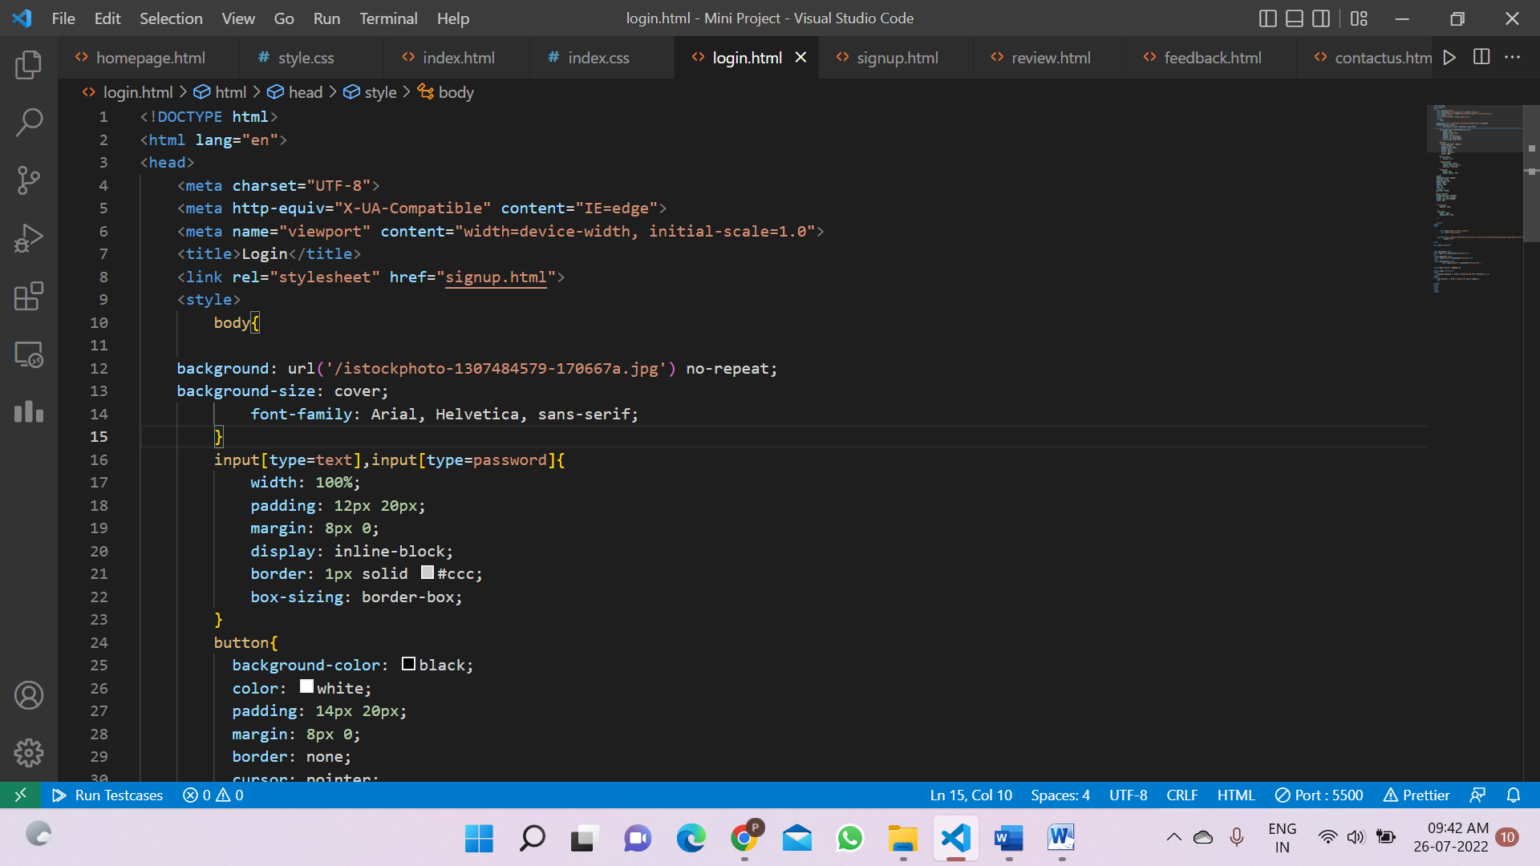

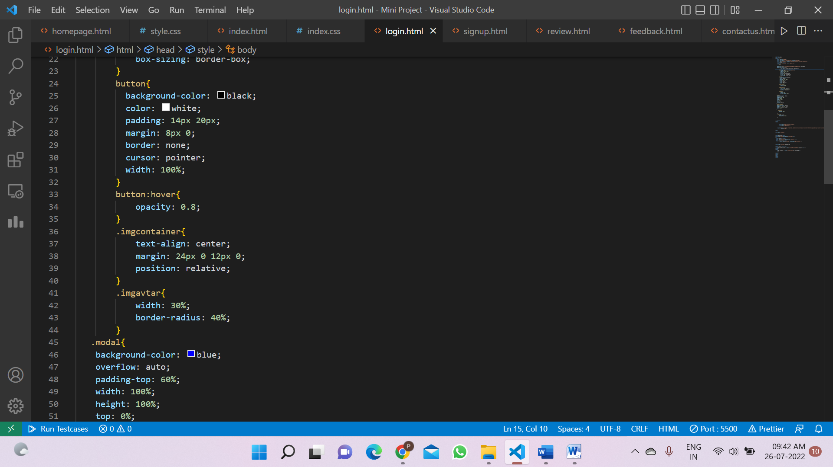

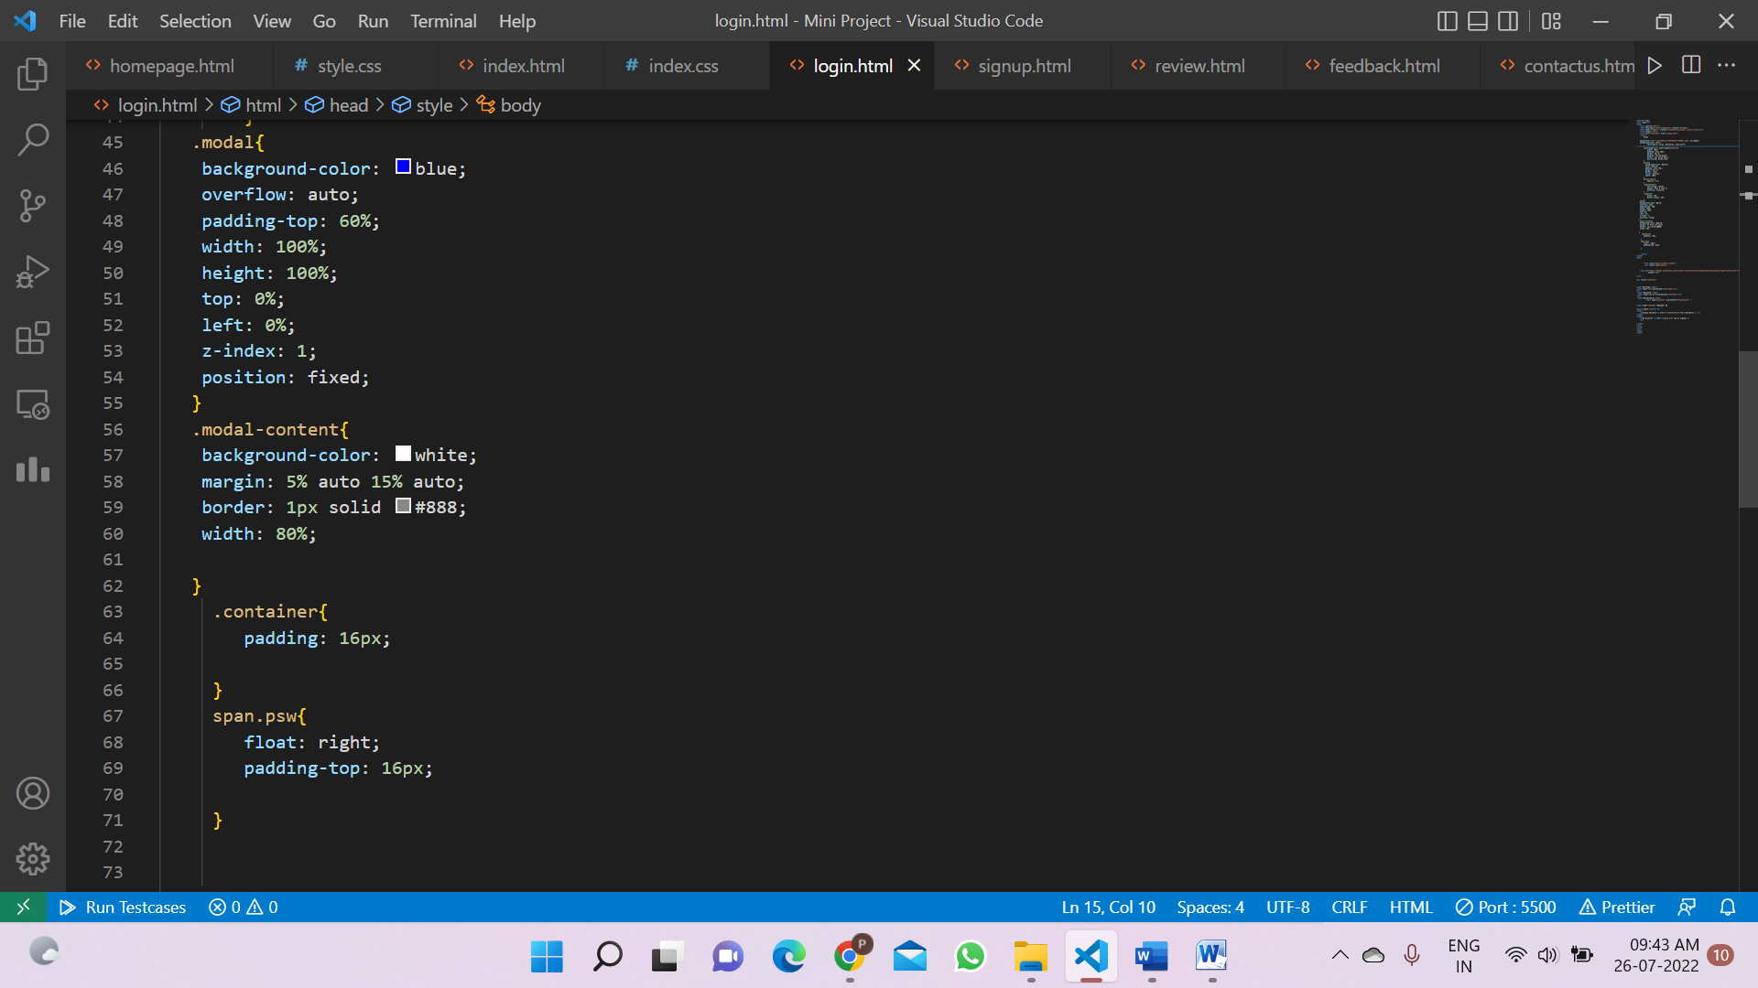

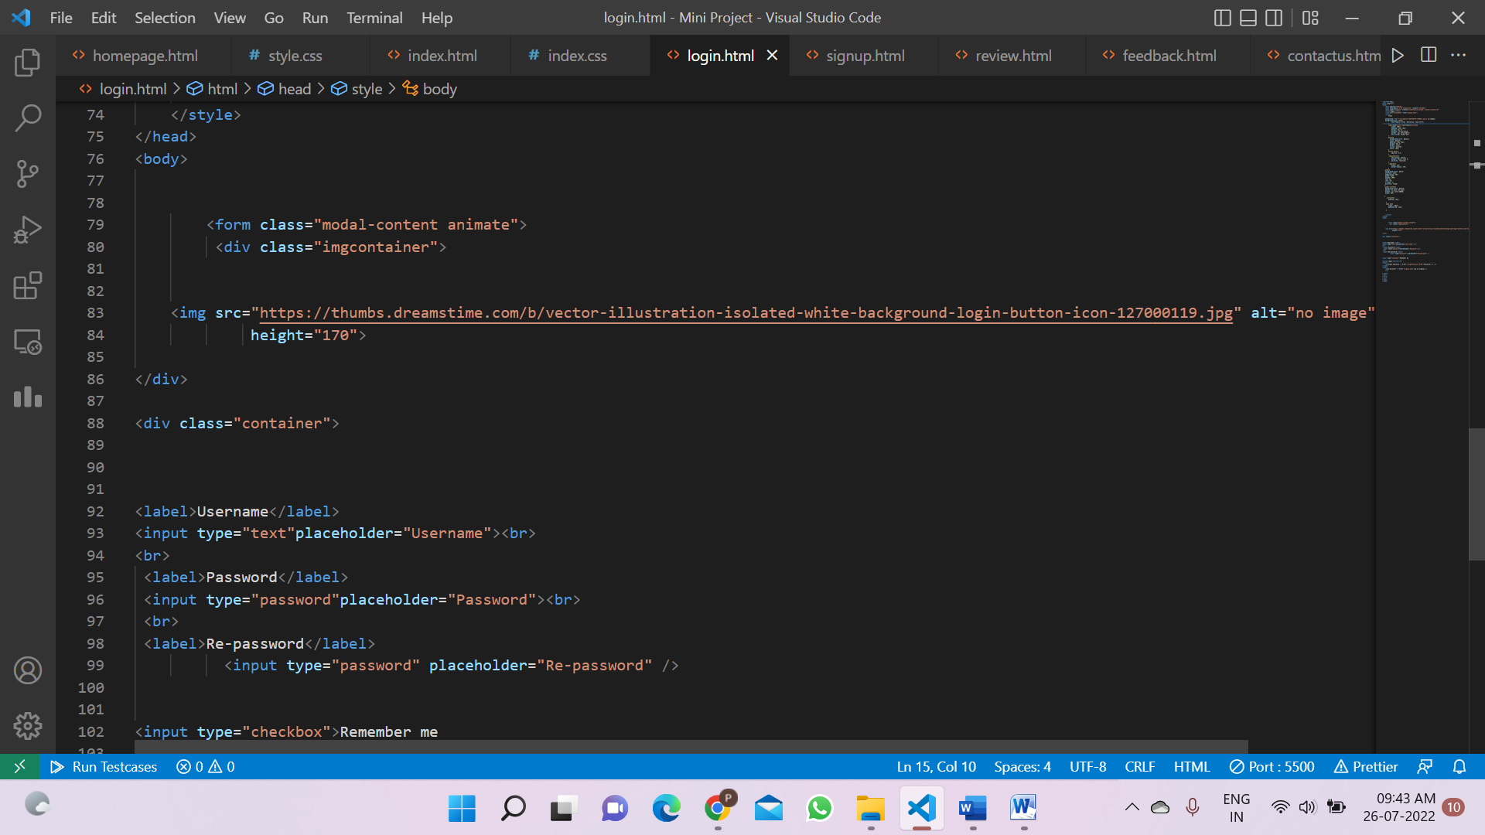

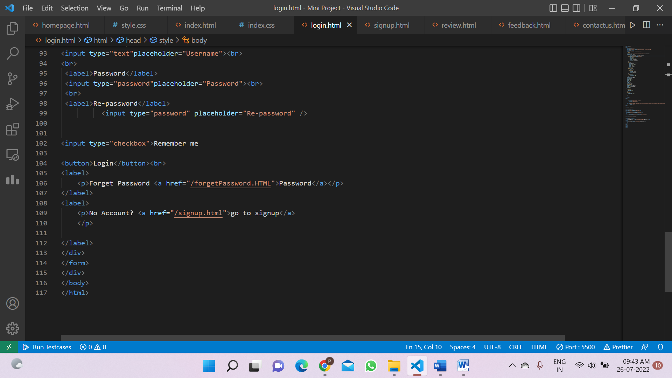

**OUTPUT:-**

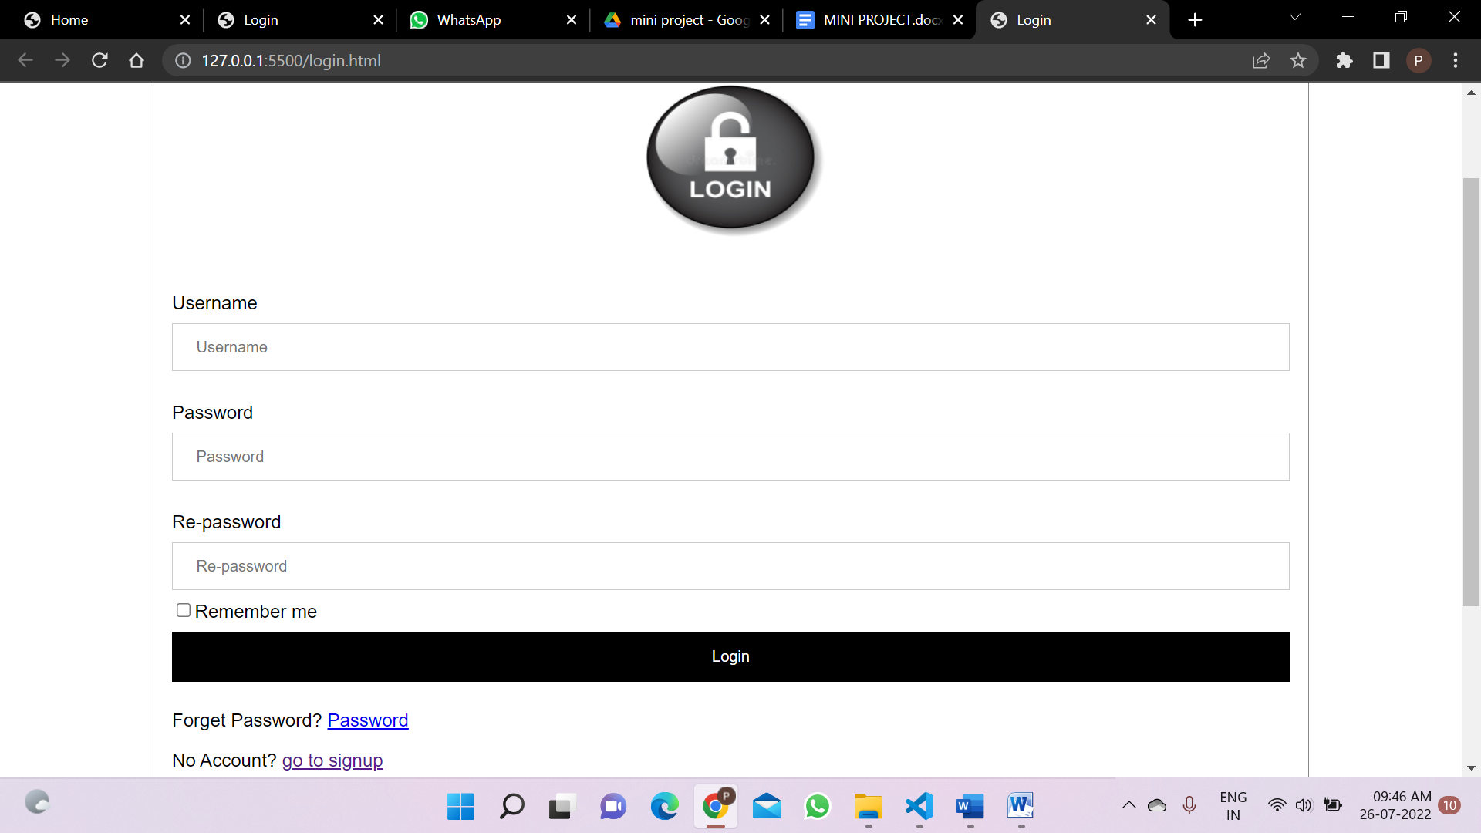

**ENTITY RELATIONSHIP DIAGRAM: -**

Salary

Profile photo

Email-id

Resume

Role

city

Address

Title

Phone no

Description

Job

Employee

Apply For

Validate

Manage

Post

Send Message

Manage

Employer

Admin

Username

Company address

Company name

email

name

username

**USE CASE DIAGRAM: -**

Manage Users & Full Application

Search Jobs

Apply for Jobs

JOB SEEKER

Manage Employee Registration

Create Profile

Manage Post Jobs

Registration/Signin & Signout

Admin

Login & Logout from Portal

Update Profile/Information

Manage Interviews

Search Jobs

Post Jobs

Search Candidates

Company

Manage Search Job

Manage Apply Count

Create Profile

**Add screenshot and code of sample data stored in database**

Still working on it